Ahmad Barakat | ITEC 422 | WIRESHARK LAB 5
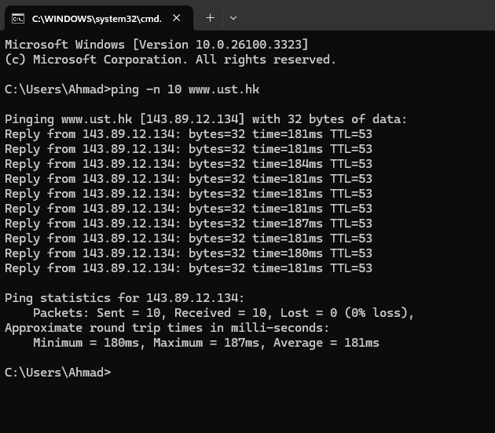

1. What is the IP address of your host? What is the IP address of the destination
host?
Using the very first packet we can see the host is 192.168.86.2.34 and the destination is 143.89.12.134.

2. Why is it that an ICMP packet does not have source and destination port
Numbers?
Unlike TCP and UDP ICMP is not a transport layer, it is used for error reporting so it is not
associated with ports.

3. Examine one of the ping request packets sent by your host. What are the ICMP
type and code numbers? What other fields does this ICMP packet have? How
many bytes are the checksum, sequence number and identifier fields?
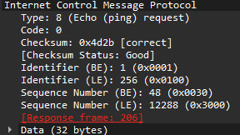
Everything is shown in the screenshot conveniently, this is accessed by looking at the very first
packet’s Internet Control Message Protocol

4. Examine the corresponding ping reply packet. What are the ICMP type and code
numbers? What other fields does this ICMP packet have? How many bytes are the
checksum, sequence number and identifier fields?
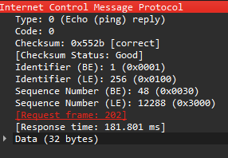
Found in exactly the same way, this time instead of using a request we are using a reply.

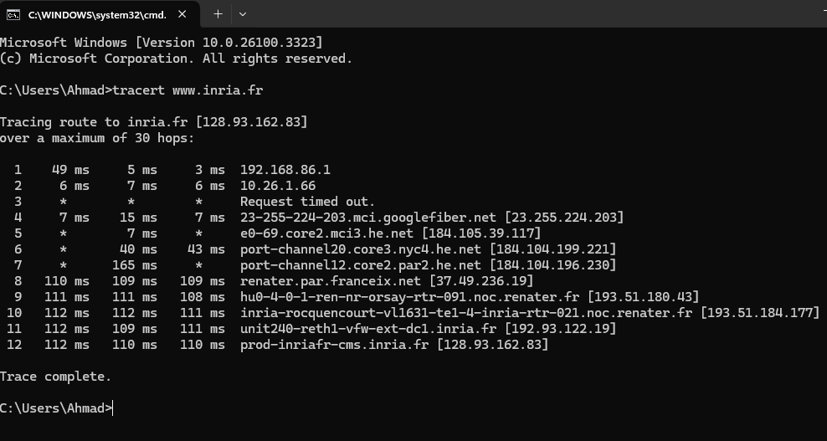

5. What is the IP address of your host? What is the IP address of the target
destination host?
Similar to question 1 we are able to see the source and destination.

6. If ICMP sent UDP packets instead (as in Unix/Linux), would the IP protocol
number still be 01 for the probe packets? If not, what would it be?
No it would not be 01, instead it would be 17 for UDP.

7. Examine the ICMP echo packet in your screenshot. Is this different from the
ICMP ping query packets in the first half of this lab? If yes, how so?
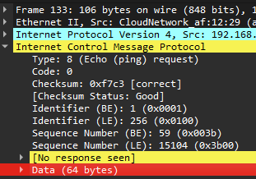
It is very similar but the sequence number and identifier are different.

8. Examine the ICMP error packet in your screenshot. It has more fields than the
ICMP echo packet. What is included in those fields?
The ICMP Error packet includes the entire IP header of the original packet, this is necessary
For the sender to identify the original packet with an error.

9. Examine the last three ICMP packets received by the source host. How are these
packets different from the ICMP error packets? Why are they different?
They are different in the fact that they show a response, because in the error message
there is no response besides the error.

10. Within the tracert measurements, is there a link whose delay is significantly
longer than others? Refer to the screenshot in Figure 4, is there a link whose
delay is significantly longer than others? On the basis of the router names, can
you guess the location of the two routers on the end of this link?
Not sure where the location of the two routers would be.

